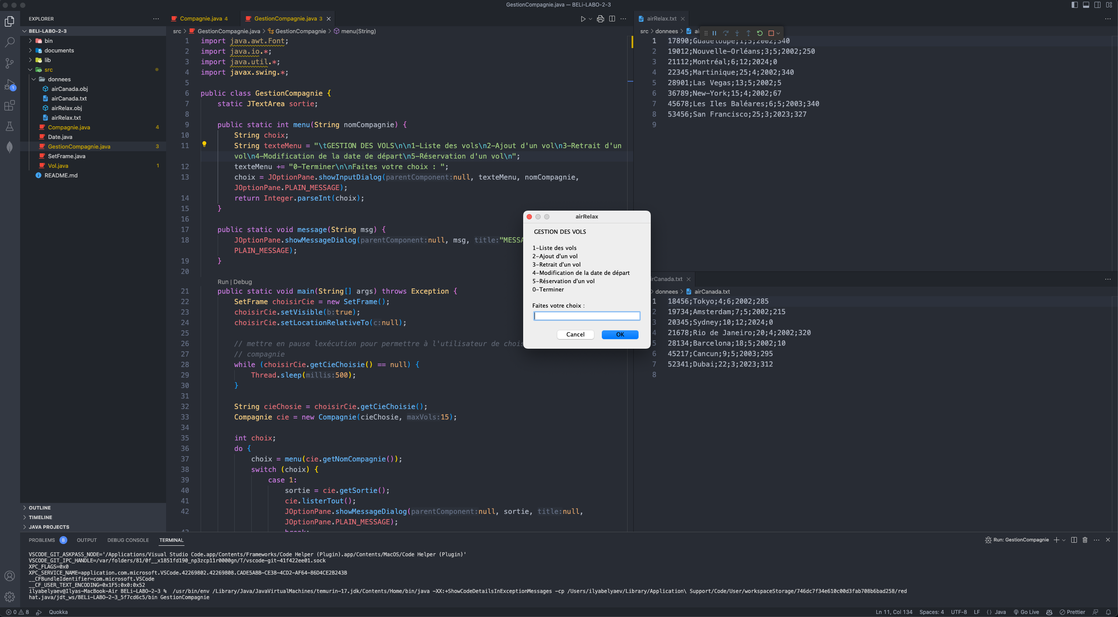

2. Ajout  
  
Ensuite on peut l’afficher :

Il sauvegarde avec le 0 sur le menu principal :  
AVANT :

APRES :

OPTION 3 : (avec air canada cette fois ci)  
on utilise le menu 1 puit afficher :  
et menu 0 pour sauvegarder :

OPTION 4 :

On suavegarde avec le 0 :

OPTION 5  
